Week7 Assignment2
Organizations often use dashboards to provide users with a simple way to access and analyze information stored in databases. Dashboards are especially useful because many users are not familiar with SQL or database systems. Instead of writing queries manually, users can interact with visual components such as charts, tables, and filters. For this assignment, I created an interactive dashboard in a Jupyter Notebook using Python, PostgreSQL, and Dash. The dashboard is based on the USDA Child Nutrition database and allows users to view food products by category and analyze food-related information through a visual interface.
Database Connection
The dashboard was connected to the PostgreSQL database nutrient_db2 using Python and the psycopg2 library. The database contains several USDA food-related tables, including ctgnme, fdes, gpcnme, and wght. These tables were originally imported in previous assignments and provided the foundation for the dashboard.
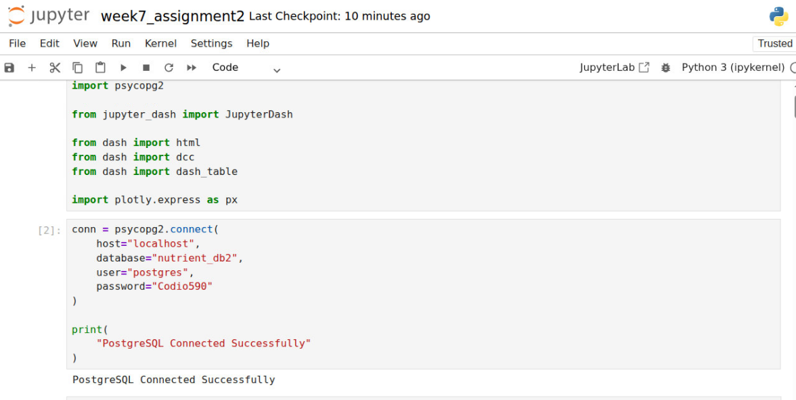The successful connection confirmed that Python could communicate with PostgreSQL and retrieve data from the USDA database. Establishing the connection was an important first step because all dashboard information depends on the ability to access the database.
Storyboard Iteration
The dashboard was based on the storyboard developed in Module Four. However, several improvements were made before implementation. In the original storyboard, the dashboard focused primarily on displaying food descriptions and category information. After reviewing instructor feedback, additional emphasis was placed on the relationship between the fdes and ctgnme tables through the Food category code field.
The updated dashboard uses Food category code as the linking field between tables and retrieves Category description from the ctgnme table. This improvement allows users to view meaningful category names rather than internal database codes. These modifications improved usability and better demonstrated the relational structure of the PostgreSQL database.
Creating Queries to Populate the Dashboard
To populate the dashboard, a SQL query was created that joined the fdes and ctgnme tables using the Food category code field. The query returned food descriptions, category descriptions, and last modified dates.
Example Query Logic:
• Retrieve food descriptions from the fdes table
• Join category information from the ctgnme table
• Match records using Food category code
• Return user-friendly category descriptions
The use of a JOIN operation demonstrates one of the primary advantages of relational databases. Instead of storing duplicate category information in multiple locations, PostgreSQL uses relationships between tables to retrieve related data efficiently.
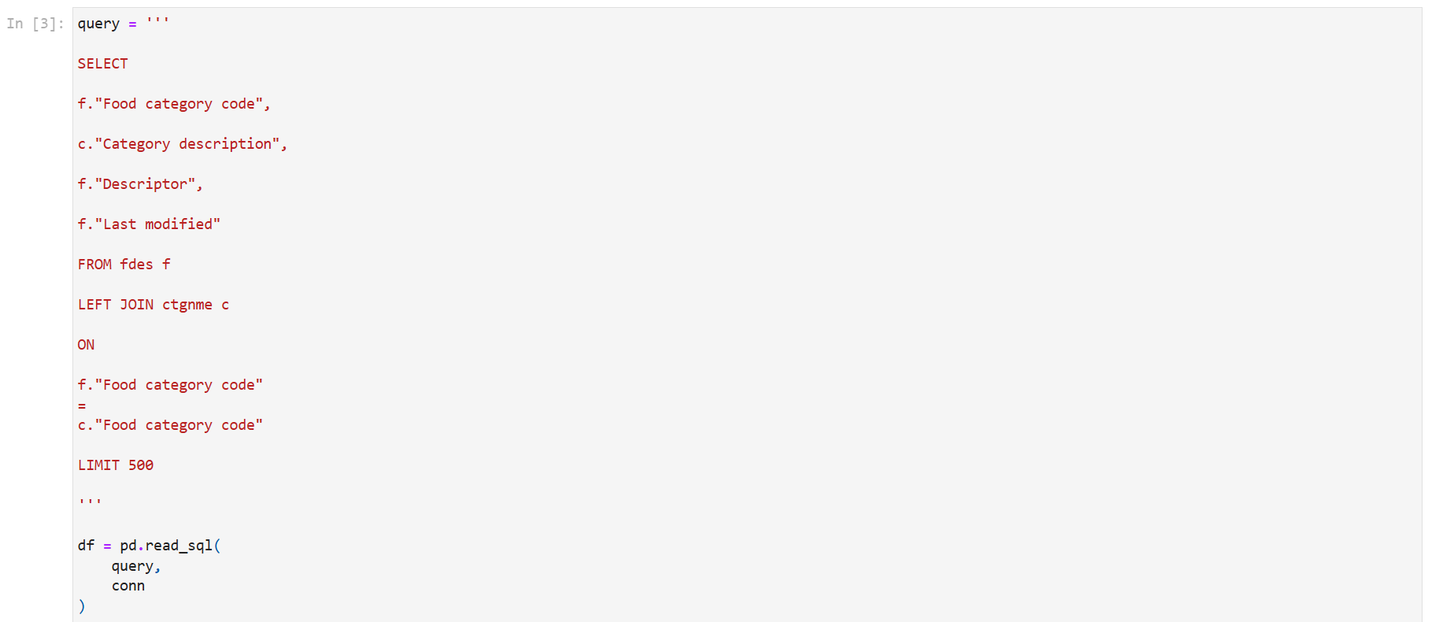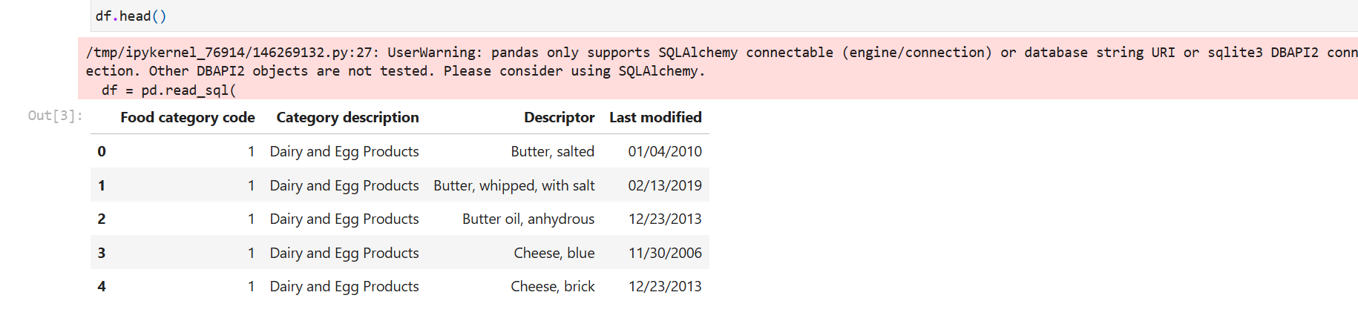
The query results confirmed that the relationship between the tables was functioning correctly. The output displayed both the category code and the corresponding category description, making the information more understandable for users.
Executing Queries
After creating the SQL query, it was executed through Python using pandas and psycopg2. The results were loaded into a DataFrame and used as the data source for the dashboard.
The query execution successfully retrieved records from the USDA database and transformed them into a format that could be visualized through charts and tables.
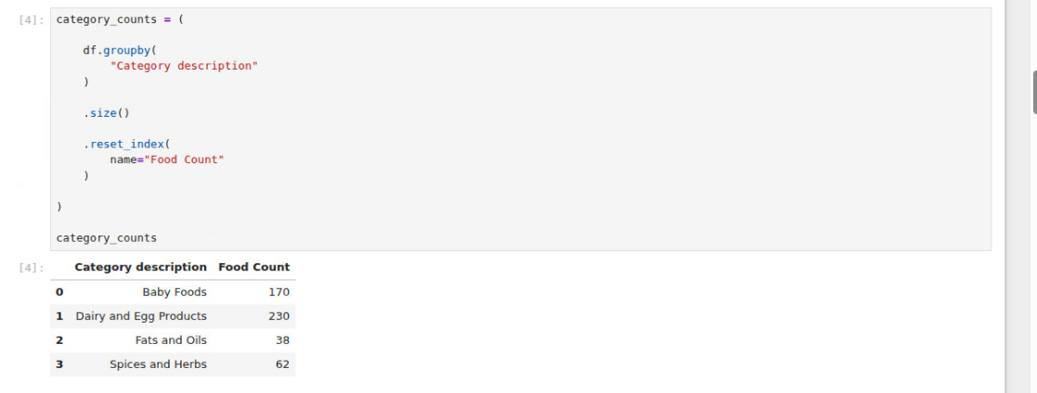
The aggregated query grouped food products by category and counted the number of food records within each category. This information was later used to generate the dashboard chart.
Dashboard Design and Implementation
The dashboard was created using Python and Dash within a Jupyter Notebook environment. The dashboard combines a bar chart and an interactive data table to provide users with multiple ways to analyze the data.
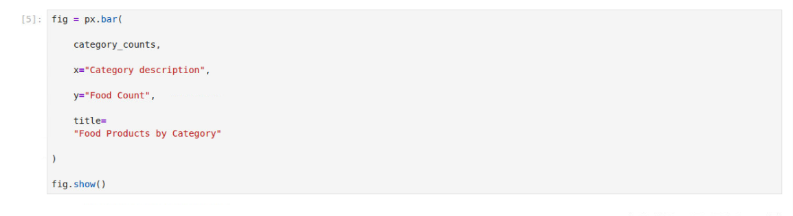
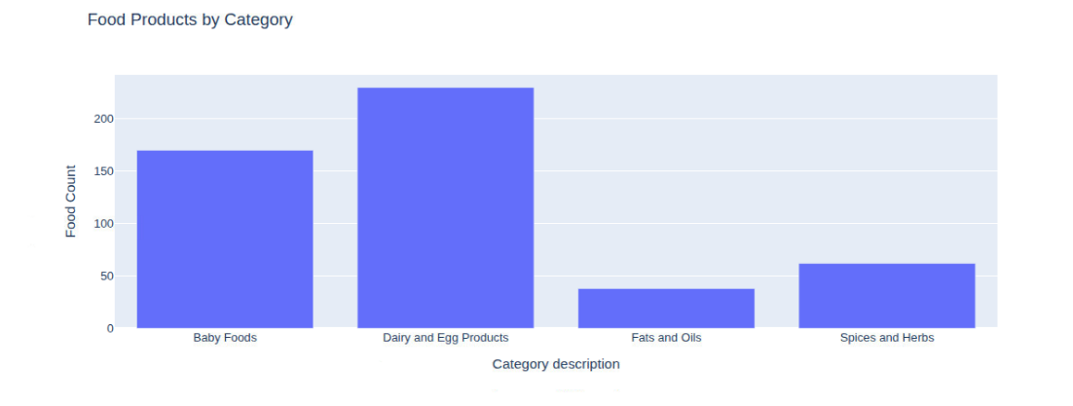
The chart visualizes the number of food products within each category. Visualizing the data in this way makes it easier for users to identify categories that contain large or small numbers of food products.
The final dashboard integrates all visual components into a single interface.
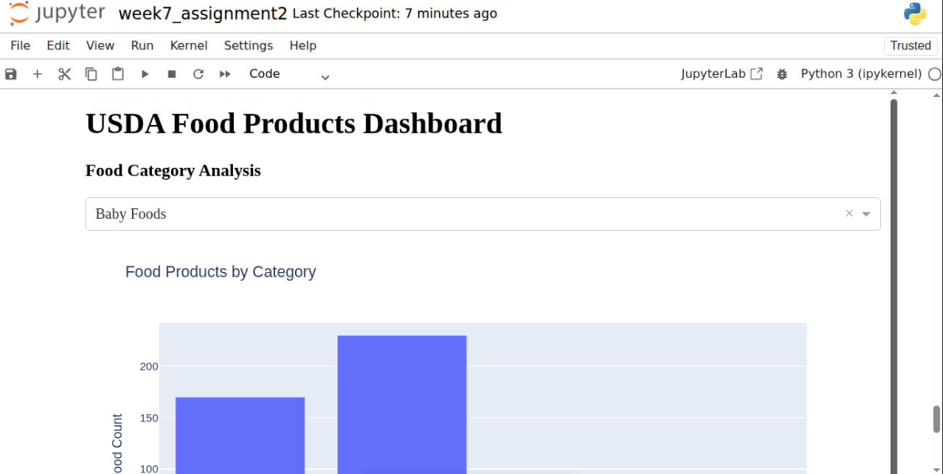

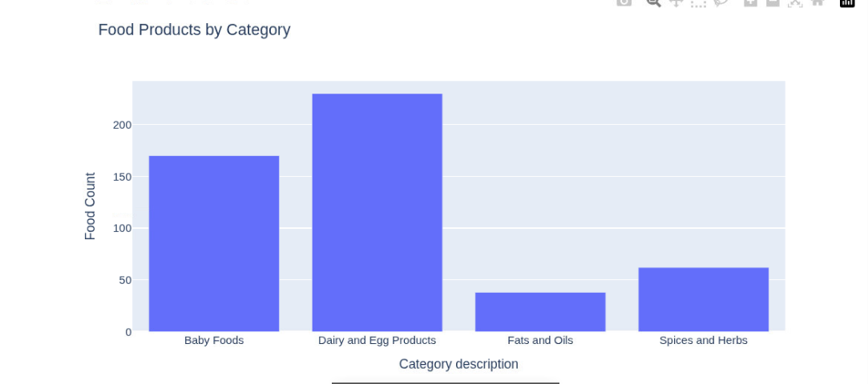
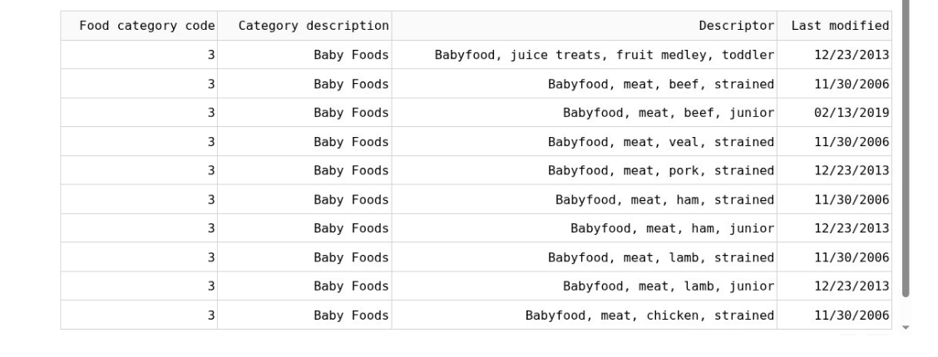

The dashboard includes a category selection component, a chart displaying food counts by category, and a table containing detailed food information. Together, these components provide users with a clear and organized view of the USDA food database.
Dashboard Description and Design Decisions
Information Included
Several types of information were included in the dashboard:
• Food category code from the fdes table
• Category description from the ctgnme table
• Food descriptor information
• Last modified dates
• Food counts by category
The inclusion of category descriptions was particularly important because category codes alone would not be meaningful to most users. By joining the ctgnme table, the dashboard presents human-readable category names that improve usability and readability.
Interactive Capabilities
The dashboard provides several interactive capabilities.
First, users can view food products grouped by category through the chart visualization. Second, the dashboard includes a category selection feature that allows users to focus on specific categories. Third, the data table allows users to review detailed food information directly within the dashboard.
These interactive capabilities support data exploration and allow users to analyze the USDA food database without writing SQL queries.
Value of Database Integration
Integrating PostgreSQL with the dashboard provides significant advantages compared to using static files such as CSV documents. PostgreSQL stores the data in a structured relational format and allows tables to be joined using Food category code.
Because the dashboard retrieves data directly from the database, any future updates to the database become immediately available without rebuilding the dashboard. Relational queries also provide faster and more efficient retrieval than scanning large flat files. The database therefore improves scalability, maintainability, and data accuracy.
Enhancing Dashboard Functionality
One enhancement that could improve the dashboard would be the addition of advanced filtering options. For example, users could filter records by category, date ranges, or GPC product codes.
Implementing this enhancement would require additional Dash components such as dropdown menus, callback functions, and parameterized SQL queries. These features would allow users to dynamically filter records and further improve the dashboard's usability.

